**Analysis of the West Coast College Campus Recycling Program**

## Presented to

## Cheryl Bryant

## Recycling Director

## Office of Associated Students

## West Coast College

Prepared by

Alan Christopher

Business Senator

Office of Associated Students

19 January, 2010

### Executive summary

#### Purpose and method of this report

West Coast’s recycling programme was created to fulfil the College’s social responsibility as an educational institution as well as to meet the demand of legislation requiring individuals and organisations to recycle. The purposes of this report are to:

* determine the amount of awareness of the campus recycling programme
* recommend ways to increase participation in the programme.

We conducted a questionnaire survey to learn about the campus community’s recycling habits and to assess participation in the current recycling programme. A total of 220 individuals responded to the survey. Since West Coast College’s recycling programme includes only aluminium, glass, paper, and plastic, these were the only materials considered in this study.

#### Findings and conclusions

Most survey respondents recognised the importance of recycling and stated that they recycle aluminium, glass, paper, and plastic on a regular basis either at home or work. However, most respondents displayed a low level of awareness of the oncampus programme. Many of the respondents were unfamiliar with the location of the bins around campus and, therefore, had not participated in the recycling programme. Other responses indicated that the bins were not conveniently located. The results of this study show that more effort is needed to increase participation in the campus recycling programme.

#### Recommendations for increasing recycling participation

Recommendations for increasing participation in the programme include:

* relocating the recycling bins for greater visibility
* developing incentive programmes to gain the participation of individuals and on-campus student groups
* training student volunteers to give on-campus presentations explaining the need for recycling and the benefits of using the recycling programme
* increasing advertising about the programme.

### 

### Table of Contents

#### 1 Introduction ..................................................................................................... 1

**1.1 West Coast’s Recycling Programme .................................................................... 2**

**1.2 Purpose of study ......................................................................................................... 2**

**1.3 Scope of the study ...................................................................................................... 2**

**1.4 Sources and methods................................................................................................. 3**

#### 2 Conclusions ...................................................................................................... 4

#### 3 Recommendations ......................................................................................... 5

#### 4 Findings and discussion ................................................................................ 6

**4.1 Recycling habits of respondents ............................................................................ 6**

**4.2 Participation in recycling on campus .................................................................... 7**

4.2.1 Student awareness and the use of bins ..................................................................... 8

4.2.2 Reasons for not participating ........................................................................................ 9

4.2.3 Location of recycling bins ................................................................................................ 9

#### References ................................................................................................................................. 10

#### Appendix

West Coast Recycling Programme Survey ............................................................................ 11

### 1 Introduction

North American society is often criticised as being a “throw away” society, and perhaps that criticism is accurate (Cahan, 2008). We discard 11 to 14 billion tons of waste each year, according to the US Environmental Protection Agency. Of this sum, 180 million tons comes from households and businesses, areas where recycling efforts could make a difference (Hollusha, 2010). According to a survey conducted by Decima Research, 73 percent of North American companies have waste reduction programmes (Schneider, 2008). Although some progress has been made, there is still a problem. For example, the annual volume of discarded plastic packaging in North America is eight billion tons—enough to produce 118 million plastic park benches yearly (Joldine, 2009). Despite many recycling programmes and initiatives, most of our rubbish finds its way to landfill sites. With an ever increasing volume of waste, estimates show that 80 percent of North America’s landfills will be full by the year 2015 (de Blanc, 2009).

To combat the growing waste disposal problem, some states and provinces are trying to pass legislation aimed at increasing recycling. Many North American communities have enacted regulations requiring residents to separate bottles, cans, and newspapers so that they may be recycled (Schneider, 1999). Other means considered to reduce waste include tax incentives, packaging mandates, and outright product bans (Hollusha, 2010). All levels of government are trying both voluntary and mandatory means of reducing rubbish sent to landfills.

#### 1.1 West Coast Recycling Programme

In order to do its part in reducing rubbish and to meet the requirements of legislation, West Coast College began operating a recycling programme one year ago. Aluminium cans, glass, office and computer paper, and plastic containers are currently being recycled through the programme. Recycling bins are located at various sites around campus, outside buildings, and in department and administrative offices to facilitate the collection of materials. The Office of Associated Students (OAS) oversees the operation of the programme. The programme relies on promotions, advertisements, and word of mouth to encourage its use by the campus community.

#### 1.2 Purpose of this study

The OAS had projected higher levels of participation in the recycling programme than those achieved to date. Experts say that recycling programmes generally must operate at least a year before results become apparent (de Blanc, 2009). The OAS programme has been in operation one year, yet gains are disappointing. Therefore, the OAS authorised this study to determine the campus community’s awareness and use of the programme. Recommendations for increasing participation in the campus recycling programme will be made to the OAS based on the results of this study.

#### 1.3 Scope of this study

This study investigates:

* potential participants’ attitudes towards recycling in general
* participants’ awareness of the campus recycling programme
* participants’ willingness to recycle on campus
* the perceived convenience of the recycling bins.

Only aluminium, glass, paper, and plastic are considered in this study as they are the only materials being recycled on campus at this time.

The costs involved in the programme were not considered in this study as we did not consider them relevant. Steelman, Desmond, and Johnson (2008) state that a recycling programme generally does not begin to pay for itself during the first year. After the first year, the financial benefit is usually realised in reduced disposal costs (Steelman, Desmond, and Johnson 2008).

#### 1.4 Sources and methods

We consulted current business periodicals and newspapers for background information and to learn how other organisations are encouraging use of in-house recycling programmes. We used these findings to formulate a questionnaire on recycling habits. This questionnaire (shown in the appendix) was then used to survey administrators, faculty, staff, and students at West Coast College campus. In all, a sample of 220 individuals responded to the self-administered questionnaire. The composition of the sample closely resembled the makeup of the campus population. Figure 1 shows the percentage of students, faculty, staff, and administrators who participated in the survey.

*Figure 1. Composition of survey sample*

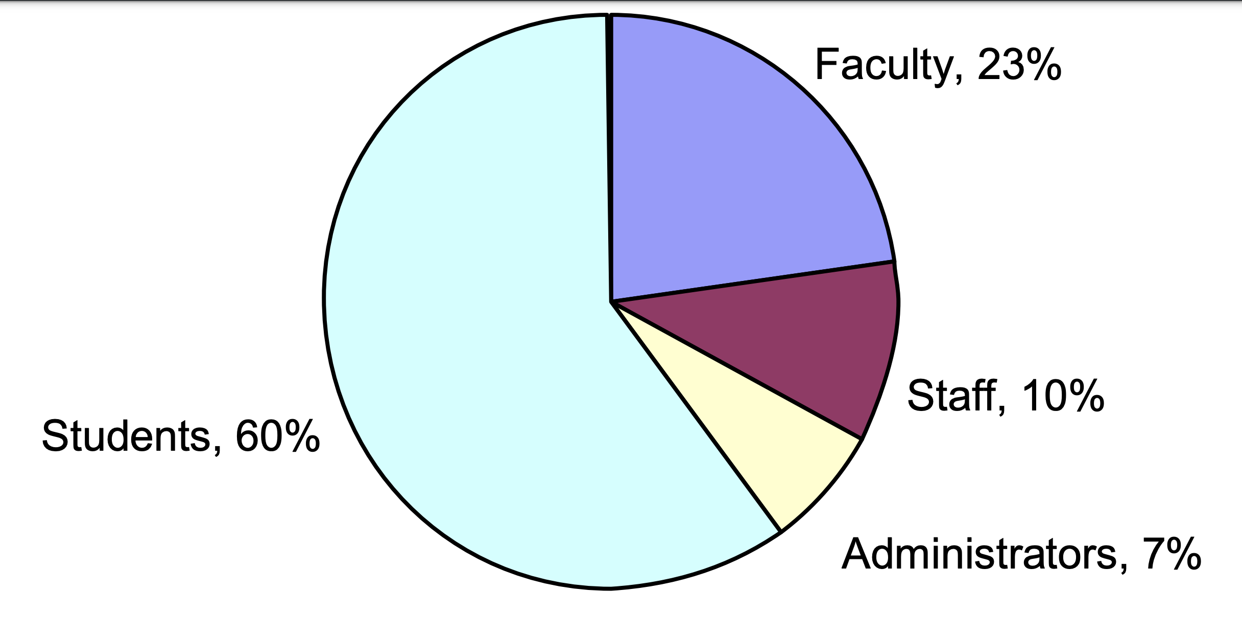

### 2 Conclusions

Based on the findings of the recycling survey of members of the West Coast College campus community, we draw the following conclusions.

1. Most members of the campus community are already recycling at home or at work.
2. Over half of the respondents recycle aluminium and paper on a regular basis; most recycle glass and plastic to some degree.
3. Most of the surveyed individuals expressed a willingness to participate in a recycling programme. Many, however, seem unwilling to travel very far to participate; 42 percent would like more recycling bins to be located inside the cafeteria.
4. Awareness and use of the current campus recycling programme are low. Only a little over a third of the respondents knew of any recycling bin locations on campus, and only a fifth had actually used them.
5. Respondents considered the locations of the campus bins inconvenient. This perceived inconvenience was given as the principal reason for not participating in the campus recycling programme.

### 3 Recommendations

After considering the findings and conclusions of this study, we offer the following recommendations in an effort to improve the operations and success of the West Coast recycling programme.

1. Increase on-campus awareness and visibility by designing an eye-catching logo for use in promotions.
2. Enhance comprehension of recycling procedures by teaching users how to recycle. Use posters to explain the recycling programme and to inform users of recycling bin locations. Label each bin clearly as to what materials may be deposited.
3. Add bins in several new locations, and particularly more in the food service and vending machine areas.
4. Recruit student leaders to promote participation in the recycling programme. These students should give educational talks to classes and other campus groups.
5. Develop an incentive programme for student organisations. Offer incentives for meeting OAS recycling goals. On-campus groups could compete in recycling drives designed to raise money for the group, the college, or a charity. Money from the proceeds of the recycling programme could be used to fund the incentive programme.

### 4 Findings and discussion

The findings of the study will be presented in two categories.

* Recycling habits of the respondents
* Participation in the West Coast College recycling programme

4.1 Recycling habits of respondents

A major finding of the survey reveals that most respondents are willing to recycle even when not required to do so. Data tabulation shows that 72 percent of the respondents live in an area where neither the city nor the region requires separation of rubbish. Yet 80 percent of these individuals indicated that they recycle aluminium on a regular basis. Although the percentages are somewhat smaller, many of the respondents also regularly recycle glass (46 percent) and plastic (45 percent). These results, summarised in Figure 2, clearly show that campus respondents are accustomed to recycling the four major materials targeted in the West Coast recycling programme.

*Figure 2. Respondents who regularly recycle at home or at work*

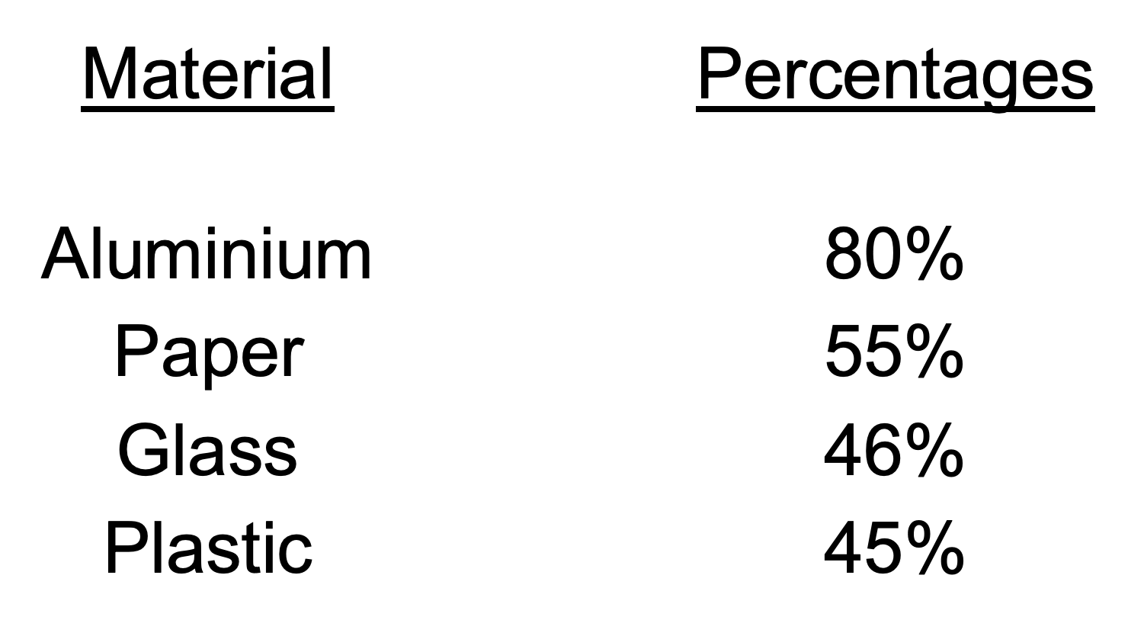

Respondents were asked to rank the importance of recycling the materials collected in the West Coast programme. Figure 3 shows that respondents felt aluminium was most important, although most also ranked the other materials (glass, paper, and plastic) as either “extremely important” or “somewhat important” to recycle. Respondents were also asked what materials they actually recycled most frequently, and aluminium again ranked first.

*Figure 3. Materials considered most important to recycle*

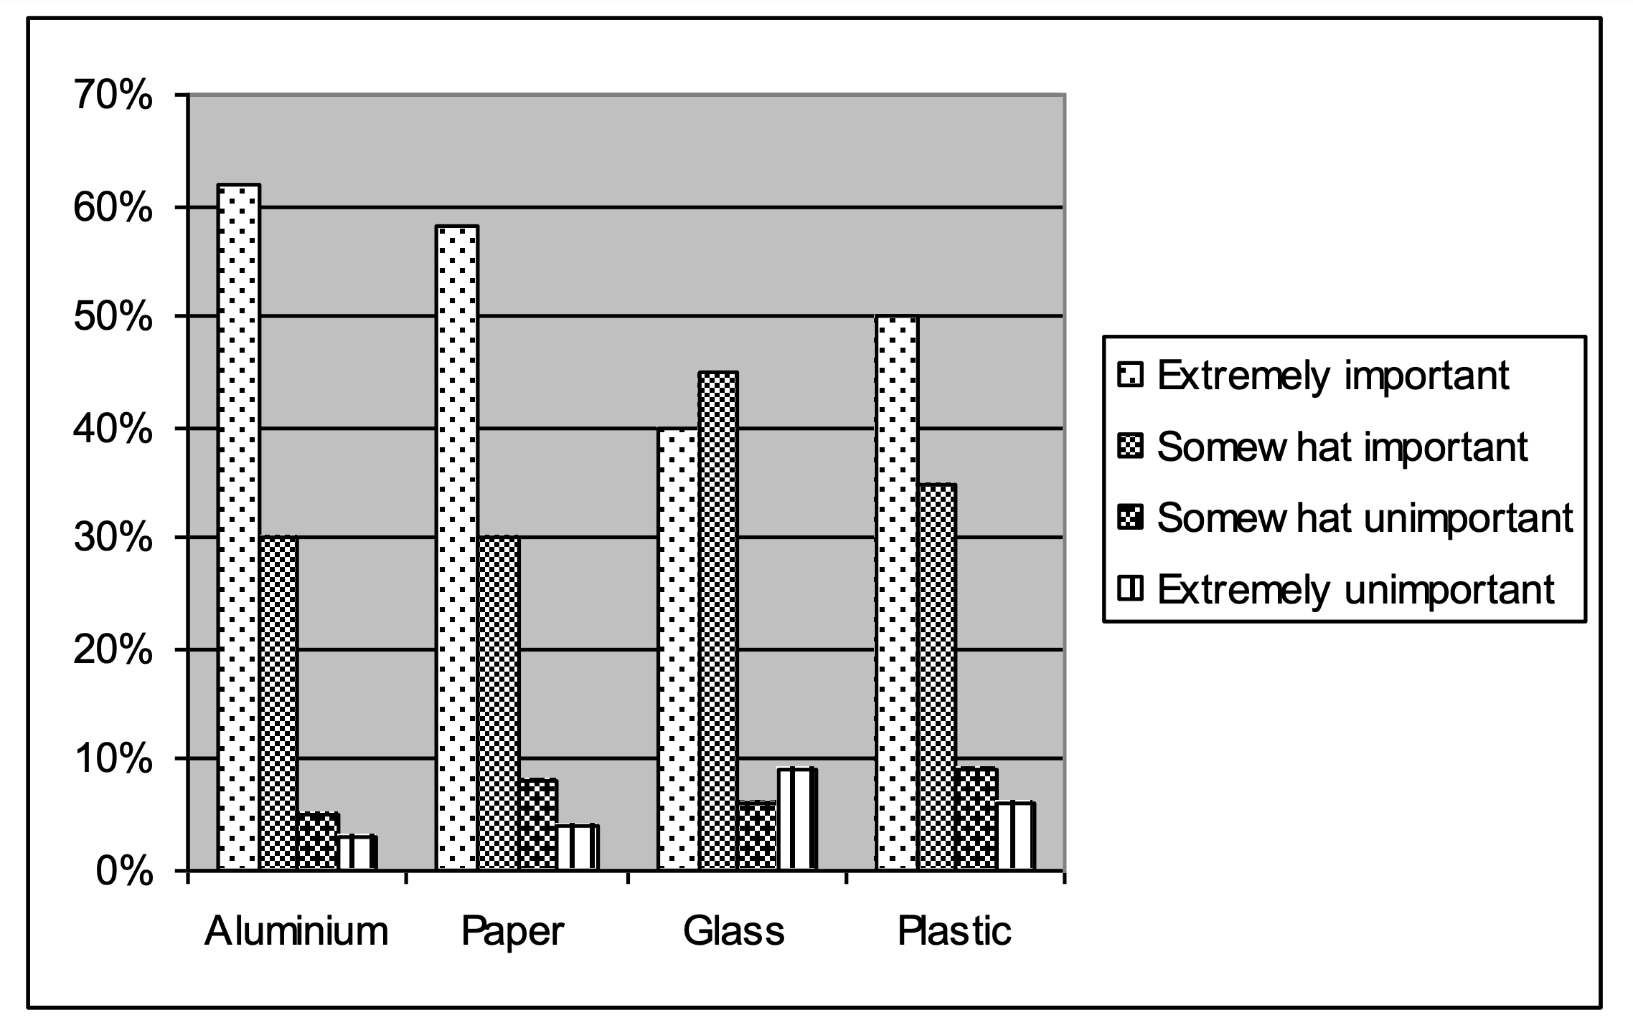

When asked how likely they would be to go out of their way to deposit an item in a recycling bin, 29 percent of the respondents said “very likely”, and 55 percent said “somewhat likely”. Thus, respondents showed willingness— at least on paper—to recycle even if it means making a special effort to locate a recycling bin.

4.2 Participation in recycling on campus

De Blanc (2009) gives factors important to any recycling programme. She states that:

* recycling centres must be in convenient locations
* participants must be aware of these locations
* participants must be trained to use recycling centres.

We incorporated de Blanc’s factors in our survey and included questions assessing awareness and use of the current bins. The survey also investigated reasons for not participating in the programme as well as reasons for the perceived convenience of current bin locations.

#### 4.2.1 Student awareness and the use of bins

Two of the most significant questions in the survey asked whether respondents were aware of the OAS recycling bins on campus and whether they had used the bins. Responses to both questions were disappointing, as Figure 4 illustrates.

*Figure 4. Awareness and use of recycling bins on campus*

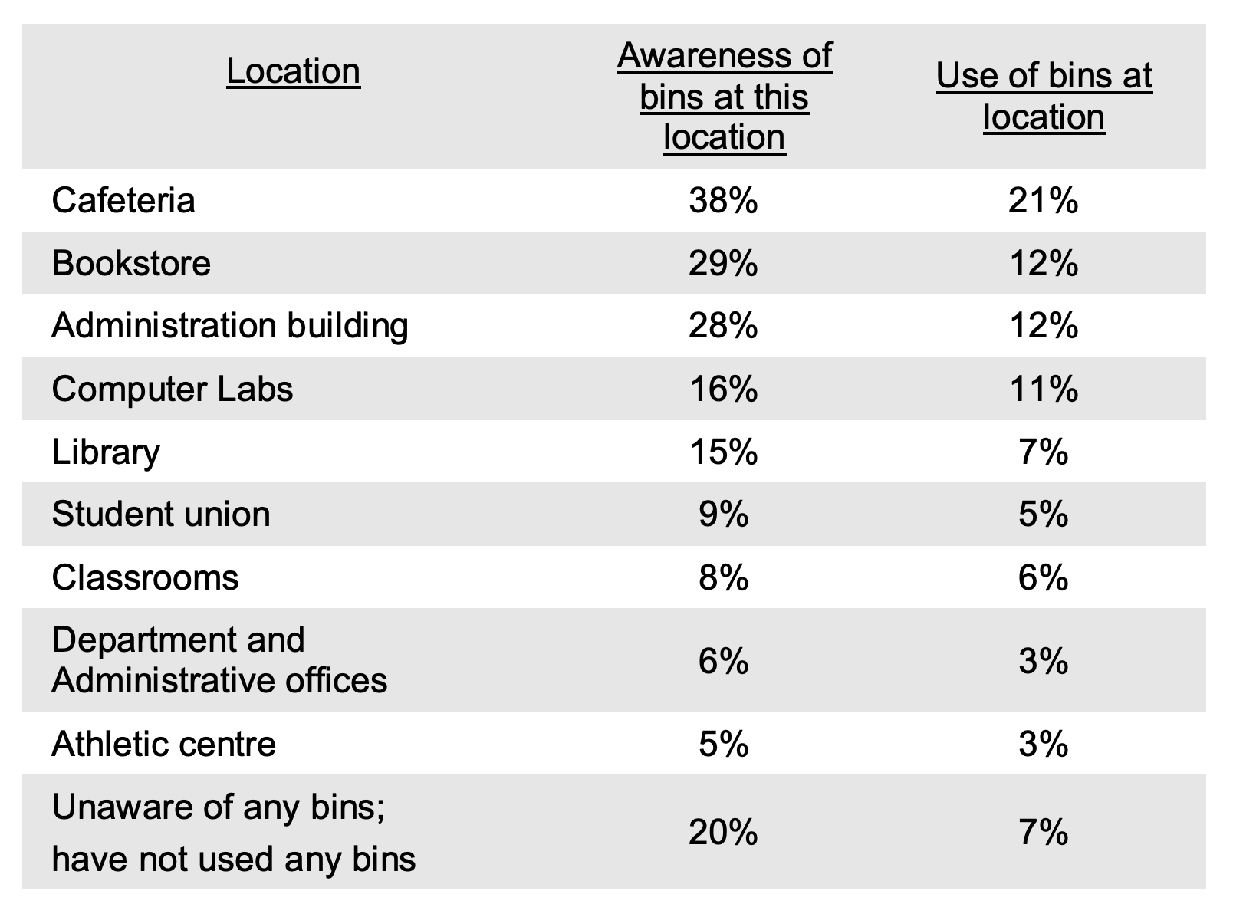

Figure 4 shows that only 38 percent of the respondents were aware of the bins located outside the cafeteria. Even fewer were aware of the bins outside the bookstore (29 percent) and outside the administration building (28 percent). Equally dissatisfying, only 21 percent of the respondents had used the most visible recycling bins outside the cafeteria.

Other recycling bin locations were even less familiar to the survey respondents and, of course, were little used. These responses plainly show that the majority of the respondents in the West Coast campus community have a low awareness of the recycling programme and an even lower record of participation.

#### 4.2.2 Reasons for not participating

Respondents offered several reasons for not participating in the campus recycling programme. Forty-five percent said that the bins were not convenient to use. Thirty percent said that they did not know where the bins were located. Another 25 percent said that they were not in the habit of recycling. Although many reasons for not participating were listed, the primary reason appears to be inconvenience of bin locations.

#### 4.2.3 Location of recycling bins

When asked specifically how they would rate the location of the bins currently in use, only 13 percent of the respondents felt that the bins were extremely convenient. Another 36 percent rated the bins as somewhat convenient. Over half the respondents felt that the locations of the bins were either somewhat inconvenient or extremely inconvenient. Recycling bins are currently located outside nearly all the major campus rooms or buildings, but respondents clearly considered these locations inconvenient or inadequate.

In indicating where they would like recycling bins placed (see Figure 5), 42 percent of the respondents felt that the most convenient locations would be inside the cafeteria. Placing more recycling bins near the student union seemed most convenient to another 33 percent of those questioned, while 15 percent stated that they would like to see the bins placed near the vending machines. Ten percent of the individuals responding to the survey did not seem to think that the locations of bins would matter to them.

*Figure 5. Preference for placement of recycling bins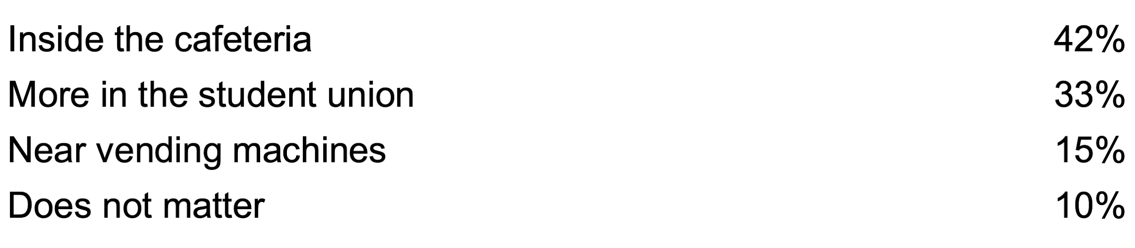*

### 5 References

Cahan, V. (2008, July 17). Waste not, want not? Not necessarily. *Business Week,* p.116.

de Blanc, S. (2009, December). Paper recycling: How to make it effective. *The Office,* 32-33.

Hollusha, J. (2010, July 26). Mixed benefits from recycling. *The New York Times,* D2. Retrieved October 26, 2010 from http://www.nytimes.com

Joldine, L. (2009). The environment and Canada’s future. In J. Davis (Ed.), Spirit of the world (pp.42-49). Waterloo, Ontario: Turnaround Decade Ecological Communications.

Schneider, K. (2008, January 20). As recycling becomes a growth industry, its paradoxes also multiply. The New York Times, p. A5.

Steelman, J.W., Desmond, S., and Johnson, L. (2008). Facing Global Limitations. New York, NY: Rockford Press.

### 

### Appendix

West Coast College recycling programme survey

West Coast College recently implemented a recycling programme on campus.

